**HOME SECURITY SURVEILLANCE ALERT NOTIFIER**

**PAHUNANG, JOHN PATRICK T.**

**FABRE, EMMANUEL REY B.**

**TAN, KYLE CEDRICK LOUISE C.**

**JUGALBOT, DENNIS LAURENTE M.**

**A RESEARCH PROJECT**

Submitted in Partial Fulfillment

of the Requirements for the Degree

Bachelor of Science in Information Technology

(BSIT)

Department of Information Technology

College of Industrial and Information Technology

Mindanao University of Science and Technology

Cagayan de Oro City, 9000 Philippines

**TABLE OF CONTENTS**

**CHAPTER**

**1**                    **INTRODUCTION**

1.1  Background of the Study                                                    1

1.2  Statement of the Problem                                                    6

1.2.1 General Problem

1.2.2 Specific Problems

1.3  Objectives of the Study                                                      6

1.4  Scope and Limitations                                                                7

1.5  Significance of the study                                                    8

**2**                    **REVIEW OF RELATED LITERATURE                          10**

**3**                    **METHODOLOGY**

3.1  Data Gathering and Analysis                                              22

3.2  System Architecture                                                           23

3.3  Context Diagram                                                                 28

3.4  Use Case Diagram                                                              29

3.5  System Flowchart                                                               30

**BIBLIOGRAPHY** 52

**LIST OF TABLES**

**Table                                              Description                                     Page**

1Comparison of Related Studies       13

**LIST OF FIGURES**

**Figure                                             Description                                     Page**

1    Diagram for Home Security Surveillance Alert Notifier       15

**CHAPTER 1**

**INTRODUCTION**

**1.1 Background of the Study**

Surveillance households is one solution to prevent home invasions.  Workaholic people have been anxious about their home security when they are out or on a trip. They want something to help them monitor their house while they are far from them. A mobile application that has eyes on his home would be a great example since it is portable and can be accessed easily.

Standard smart security cameras connect to Wi-Fi, allowing us to remotely livestream images of our system and receive alerts when our cameras detect movement, persons, or parcels. Many cameras come with infrared or color night vision, cloud or local storage, and two-way audio, allowing us to communicate with whoever is on camera. Also some of the cameras can be hooked up with smart platforms like Google Assistant and Amazon Alexa.

The only flaw of the common security surveillance system is that it cannot report immediately to the police department. But with our Alert Notifier the Police will be immediately notified whenever the alarm is triggered or when the AI senses something in the house while it’s in lockdown.

There are existing applications like Google Smart Home, Automated Security Home System and many more. But they focus on smart home appliances and gadgets. Our team wants to develop and innovate an IOT device that scans people who are inside the home and detects if it is an intruder or a family member. It is named the Home Security Surveillance Alert Notifier.

       This study will be focusing on an Internet-of-things (IOT) device that can scan images inside your home. This will be used as a form of security when you don’t have someone to look for your house. It is accessible through a mobile application. The disadvantage/downfall of the project is only the will of the police department whether they would check the alert we’re going to send them when the alarm is triggered.

**1.2 Statement of the Problem**

The researchers have a concern regarding the problems of the study.To obtain all the data, knowledge, and information, the researcher sought the crucial question as follow:

1. Security
2. Notification (App/SMS/Web)
3. Facial Recognition (Face Coverings)
4. Automated Message
5. Internet Connection/Network Problems
6. Storage/Cloud
7. Camera/Video Quality
8. Commercial pricing

**1.2.1 General Problem**

Security is one of the key factors in our houses/offices/buildings.According to Security The Loss Prevention Standard (LSP 2082 : Issue 1.0) For business and residential owners, security is important. as well as the security of the property. It is also important to guard equipment, staff, visitors, and data. Security may be a very important consideration on construction sites.

**1.2.2 Specific Problems**

**Notification**

Most mobile app users can have control over the notification, they can adjust if they want to be notified on the app. According to NYTimes, Android's notifications settings provide several levels of control over app alerts, including priority preferences. In another article from Apple Support said, Most notification settings can be customized for each app. Users can also receive SMS/Text messages from the app if the user registered the mobile number on the app. An automated text will be received to notify the user if a problem occurs in the house. On the Web both users and the Police IT Department can view the Image taken from the surveillance camera that was sent from Google Drive then notified on  the Web.

**Facial Recognition**

Facial recognition technology is helping to overcome the issues caused by face coverings for identification. However, the researchers are not yet fully aware of this technology, and are still discovering how to implement the technology on the cameras that were used.

**Automated Message**

Researchers are exploring these features to be added for the Mobile Application to have a user-friendly notification system. Even though the user went offline, an automated text will be received on the user’s end.

**Internet Connection/Network Problems**

The Internet and Network Problem is one of the main problems in this study. Researchers come with an idea that will cope with these problems. Automated Texts, Cloud Upload Delay, and Adjustment on the Service Provider that depend on the location.

**Storage/Cloud**

The Image taken from the surveillance camera will be sent from Google Drive then notified on  the Web. The Google Drive Link will be shown on the Web and App to view the image. According to Google FAQs, Every Google Account comes with **15 GB** of storage that's shared across Google Drive, Gmail, and Google Photos. That is the reason why only the images will be sent online. The video coverage will only be saved on the Hard Drive for a video review.

**Camera/Video Quality**

Image and Video processing is an important key to this study. The quality of the picture captured from HD security cameras is probably the single biggest advantage IP CCTV systems have when compared with traditional analog systems. Researchers had the idea to have high end IP Cameras to identify the surroundings clearly.

**Commercial pricing**

Based on the prices for IP Cameras used, Hard Drive, and Cloud. Researchers concluded that this study is expensive and not cost-efficient. It will be suggested for the Middle and High Class Houses and Subdivision Houses

**1.3 Objectives of the Study**

**1.3.1 General Objective**

The general objectives of Home Security Surveillance Alert Notifier is to ensure the safety and full control of your home by monitoring and navigating with the use of mobile applications while you are far away from home. We created this program to help you guard your home real-time to reduce the chance of getting your home invaded by robbers and any unwanted guests. It views inside and out footage to let you know who is in your home. It will be accessible using your smartphones and computers . It is a mobile application connected to the website of the nearest police department. We conducted interviews with the police authorities and possible users .

**1.3.2 Specific Objectives**

The proposed system specifically aims to:

* To design a user-friendly application that can access your IP camera at home. Researchers will also create a website for the police department where the notifications will be sent when an alarm or breach happens.
* To evaluate how our application affects the home security of the users . and also helps the police department notify or send some tip if something not right is happening in someone's home .
* To develop an mobile application that has a full-view of your smart home real-time and has the feature to send notifications straight to the police department .
* Researchers will apply all possible ways to communicate or notify the user and the police department immediately for example the automated messages and automated emails . Two is better than one that is why the researchers included notifications with the use of the internet and network . This can also solve future problems when a connection is down , it can use the network . Same with if a network is down , they can use the internet.
* The facial recognition using image processing needs a lot of storage to store. That is why the researchers planned out that they will be using two storages which are cloud storage and local storage. For the system to be efficient and be capable of recording long hours. Since the researchers will be using a High-Definition Camera it will take up too much storage that is why we need to strategically store the data properly to maximize its use.
* The use of high-definition cameras will cost a lot that is why we need to find an affordable camera to test it out . The researchers should invest in it since they will be focusing on facial recognition . Facial details are crucial for scanning so it needs to be good in capturing images .

**1.4  Significance of the Study**

Home invasions are rampant nowadays , their target are those rich households that have less security to make their home invasion job easy . Some of the security in a household are not efficient, namely security guards and CCTV cameras . Security guards can miss a chance because sometimes they will get tired and sleep so that's the chance of the burglary to happen . Also CCTV cameras are only to record such happenings to provide strong evidence yet the burglary will still happen . Our home security is a hybrid of a CCTV camera but it has more advanced features that will help users efficiently .It will have facial recognition and an easy-access to the users through mobile phone or computer . It will also have facial recognition that will scan the faces of a person and send notifications to the users whether they want to report it immediately .

       People that are capable of spending for a system that will recognize or guard their house and check who is inside their homes.The most beneficiary of our application are people who often get out of their homes due to work or travel but still want to safeguard their homes .

* Future researchers can use this study if they want to innovate a bigger project using a facial recognition feature or image processing using an IOT device that sends notifications to authorities .
* They can also use our program and system how it works from image processing to automated notifiers on the local authorities or to somebody that needs it .

**1.5 Scope and Limitations**

         The scope of the study would be only home security using facial recognition in an IOT connected to the mobile application that has direct contact to the police department via website. This will only focus on developing a mobile application using an IOT device that sends data to our created website in the police department.

Homes that have the privilege to install a surveillance camera for their home security .Involves making homes even smarter with just the use of one device. Homes are interfaced with sensors including motion sensors, and facial recognition provide automated toggling of devices supported by conditions.The systems are often integrated closely with home security solutions to allow better control and safety for users/owners. It has a real-time view of your home , helps you notify the authorities immediately to respond if there is something detected in your home .

The limitations of this study would only be facial recognition on an IOT device connected with an app and connection between users and the local police department only .

**CHAPTER 2**

**REVIEW OF RELATED LITERATURE**

This chapter contains concepts, a completed thesis, generalizations or findings, techniques, and other items. Those included in this chapter helps in familiarizing information that is related and comparable to the present study.

# Intelligent surveillance system with integration of heterogeneous information for intrusion detection Recently, there has been an upsurge in interest in security in public and private areas in favor of social welfare. Surveillance systems are becoming increasingly important in providing security for persons and infrastructure. Currently, many buildings are outfitted with cameras, sensors, or microphones. It is, however, difficult to discover tools that combine information from different sources into a unified system. Intruder detection, on the other hand, is becoming increasingly important in the corporate, commercial, and private sectors. For these reasons, we present a multi-sensor intelligent system that analyzes data from several sources (video, audio, and other sensors) to detect harmful or interesting incursions. As a result, we created a generic ontology that allows us to integrate all of the input diverse knowledge in a homogenous manner. We present a rule-based paradigm for performing intrusion analysis, which processes all information collected from the monitored environment. Because the criteria that characterize an incursion in a semantic form may be adjusted based on the context and circumstances, this model is easily flexible and changeable. When an intruder is detected, the system sounds an alarm. Furthermore, this warning is sent to mobile devices. As a result, the system reports in real time based on the capabilities of the device, providing a context-sensitive notice. ( J.L. Castro, M. Delgado, J. Medina, M.D. Ruiz-Lozano (2011). )

Home Monitoring System Based On Android Platform

Background subtraction methods are widely used for moving object detection in videos in many applications, such as traffic monitoring, human motion capture, and video surveillance. H.264 relies on this method for its encoding and decoding logics. We stream and monitor in real time for surveillance purposes by designing a mobile application that works with the powerful android platform and the H.264 encoding technique that uses the background subtraction method. Face detection and motion detection improve our purpose and address the issue of mobile device storage capacity. ( Prof. S.N. Dadange, Mr. Sunny Wagh, Mr. Ganesh Santpal, Mrs. Pooja Patil, Mr. J Vignesh (2017). )

# An advanced Internet of Thing based Security Alert System for Smart Home

# Prior to the introduction of the Internet of Things (IoT), personal computers and laptops were used to conduct daily duties such as mail browsing, access to bank portals, and monitoring current temperature, among other things. Due to the rapid rise of IoT, they are now using IoT-enabled smart devices such as smart mobile phones, PDAs, and tablets for such duties. Because of its numerous benefits, smart homes have gained widespread acceptance among individuals and businesses worldwide. Home security systems can be defined as monitoring of a complete home/some portion of home from a remotely located or centralized location. It enables the user to monitor all actions within the property from a remote place, ultimately providing pleasure to the home's owner. Many home security systems exist, but they have some problematic drawbacks, such as latency, non-web enabled, and difficult to handle during alert transfer to users in case of any odd incident within the home. If an unexpected occurrence occurs within a house where security systems are installed, the system must be capable of immediately alerting the user through phone, text, or email. Cameras and other cutting-edge network technology have made it possible for us to remotely monitor our homes from our smartphones in a more effective and efficient manner. In light of the foregoing, we propose in this article an advanced Internet of Things-based Security Alert System for Smart Home to detect an intruder or any unexpected incident at home while no one is there. This low-cost home security system makes use of a tiny pyroelectric infrared (PIR) module and a raspberry pi to minimize the delay during the e-mail alert procedure. This article further confirms the versatility and broad applicability of the Raspberry Pi. Preliminary analyses have yielded promising findings. ( S. Tanwar, P. Patel, K. Patel, S. Tyagi, N. Kumar and M. S. Obaidat (*2017). )*

**Comparison of Related Studies**

|  |  |  |  |  |
| --- | --- | --- | --- | --- |
| **TITLE** | **FEATURE 1**  **(FACIAL RECOGNITION)** | **FEATURE 2 (MOTION SENSOR)** | **FEATURE 3 (ALARM NOTIFICATION)** | **FEATURE 4 (REAL-TIME)** |
| Home Security Surveillance Alert Notifier | **✓** | **✓** | **✓** | **✓** |
| Intelligent surveillance system with integration of heterogeneous information for intrusion detection |  | **✓** | **✓** | **✓** |
| Home Monitoring System Based On Android Platform | **✓** | **✓** |  | **✓** |
| An advanced Internet of Thing based Security Alert System for Smart Home |  | **✓** | **✓** | **✓** |

**CHAPTER 3**

**METHODOLOGY**

 In today’s society, science and technology have changed our lives. Video surveillance (CCTV) can provide us with security monitoring of our property.

A video surveillance system/CCTV consists of a system of cameras, monitors/display units, and recorders. Cameras could also be either analog or digital with a number of possible design features.

The steps to install CCTV

* Various types of IP cameras are installed on a wall
* Various types of IP cameras communicate with the switch
* The hard disk video recorder is connected to the switch
* The display is used to display the output images or video
* Configure NVR for IP Camera on a Network

Researchers propose a methodology to solve the problem by making a website to send information from the datas of the cameras. Also by placing the cameras to spots with wide view coverage.

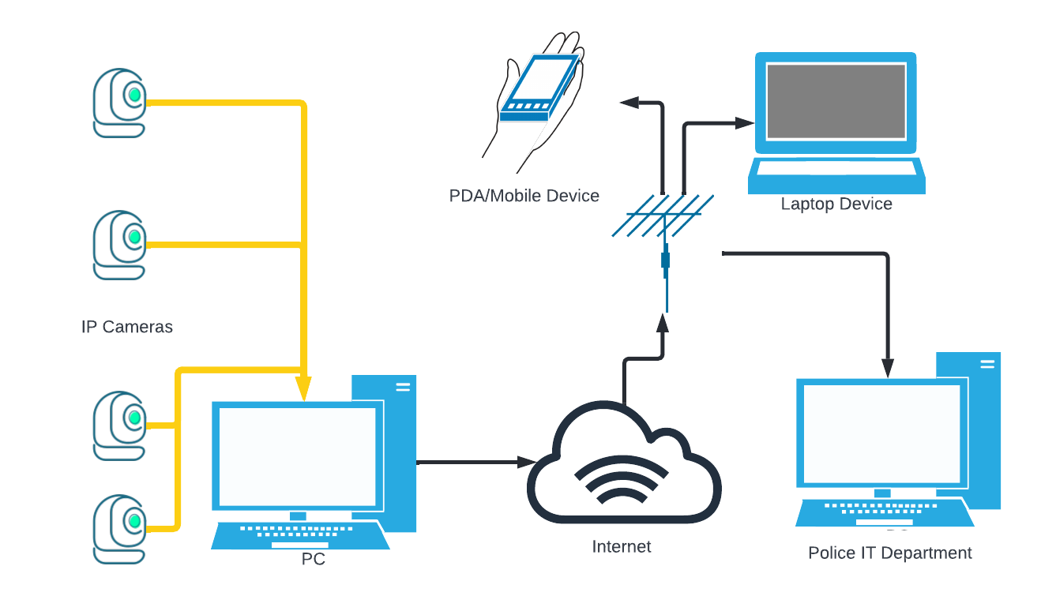

Figure 1.0 Diagram for Home Security Surveillance Alert Notifier

The performance of computer vision systems for measurement, surveillance, reconstruction, gait recognition, and plenty of other applications, depends heavily on the location of cameras observing the scene. This work addresses the question of the optimal placement of cameras to maximize the performance of real-world vision systems during a kind of application.

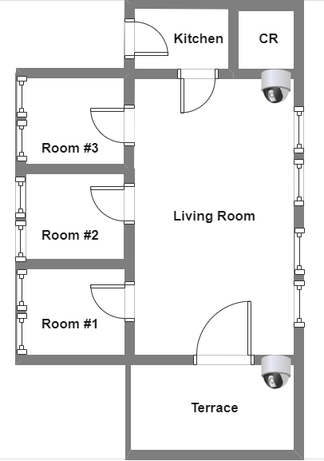

Figure 1.1 Floor Plan for Home Security Surveillance Alert Notifier

Specifically, our goal is to optimize the combination observability of the tasks being performed by the topics in a locality. We develop a general analytical formulation of the observation problem, in terms of the statistics of the motion within the scene and therefore the total resolution of the observed actions that's applicable to several observation tasks and multi-camera systems. An optimization approach is employed to search out the inner and external (mounting position and orientation) camera parameters that optimize the observation criteria. We demonstrate the strategy for multi-camera systems in real-world monitoring applications, both indoor and outdoor.

**BIBLIOGRAPHY**

Intelligent surveillance system with integration of heterogeneous information for intrusion detection: <https://www.sciencedirect.com/science/article/abs/pii/S0957417411003897>

Home Monitoring System Based On Android Platform: <https://www.ijirmf.com/wp-content/uploads/2017/05/201704066.pdf>

# An advanced Internet of Thing based Security Alert System for Smart Home:

# <https://ieeexplore.ieee.org/abstract/document/8035326>

Security

[The Loss Prevention Standard (LSP 2082 : Issue 1.0)](https://www.redbooklive.com/download/pdf/LPS-2082-Issue-1.0.pdf)

[How to Take Control of Your Notifications - The New York Times (nytimes.com)](https://www.nytimes.com/2020/02/05/technology/personaltech/control-phone-notifications.html)